**Data Visualization Using Tableau - 2**

**Assignment – 1**

**Word Cloud Chart**

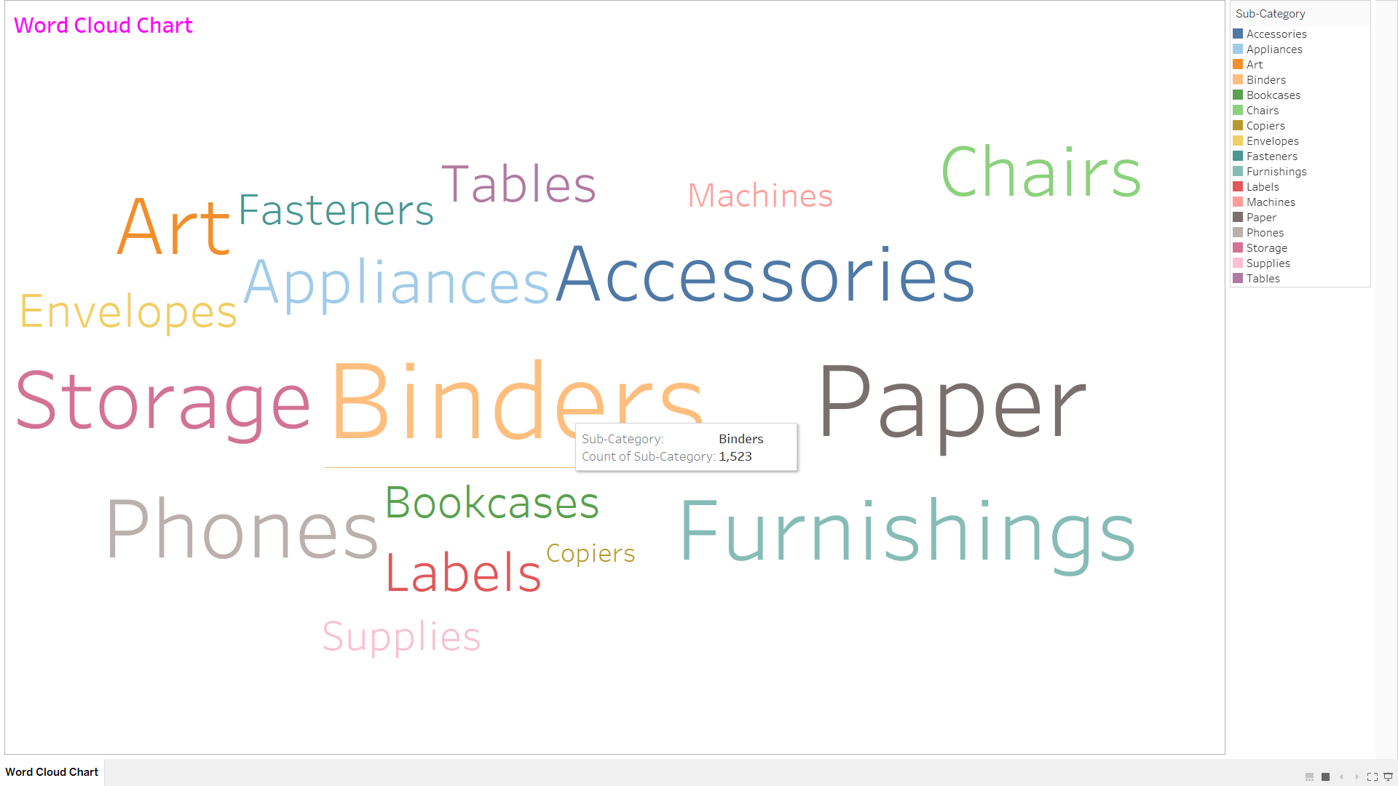

**Control Chart**

